## Locations and Neighborhoods:

Today, the Landon is located in 20 countries and 400 neighborhoods, around the world. Each hotel gives a glimpse into the unique culture and vibe of its locale. Some of the most popular and eclectic locations are as follows:

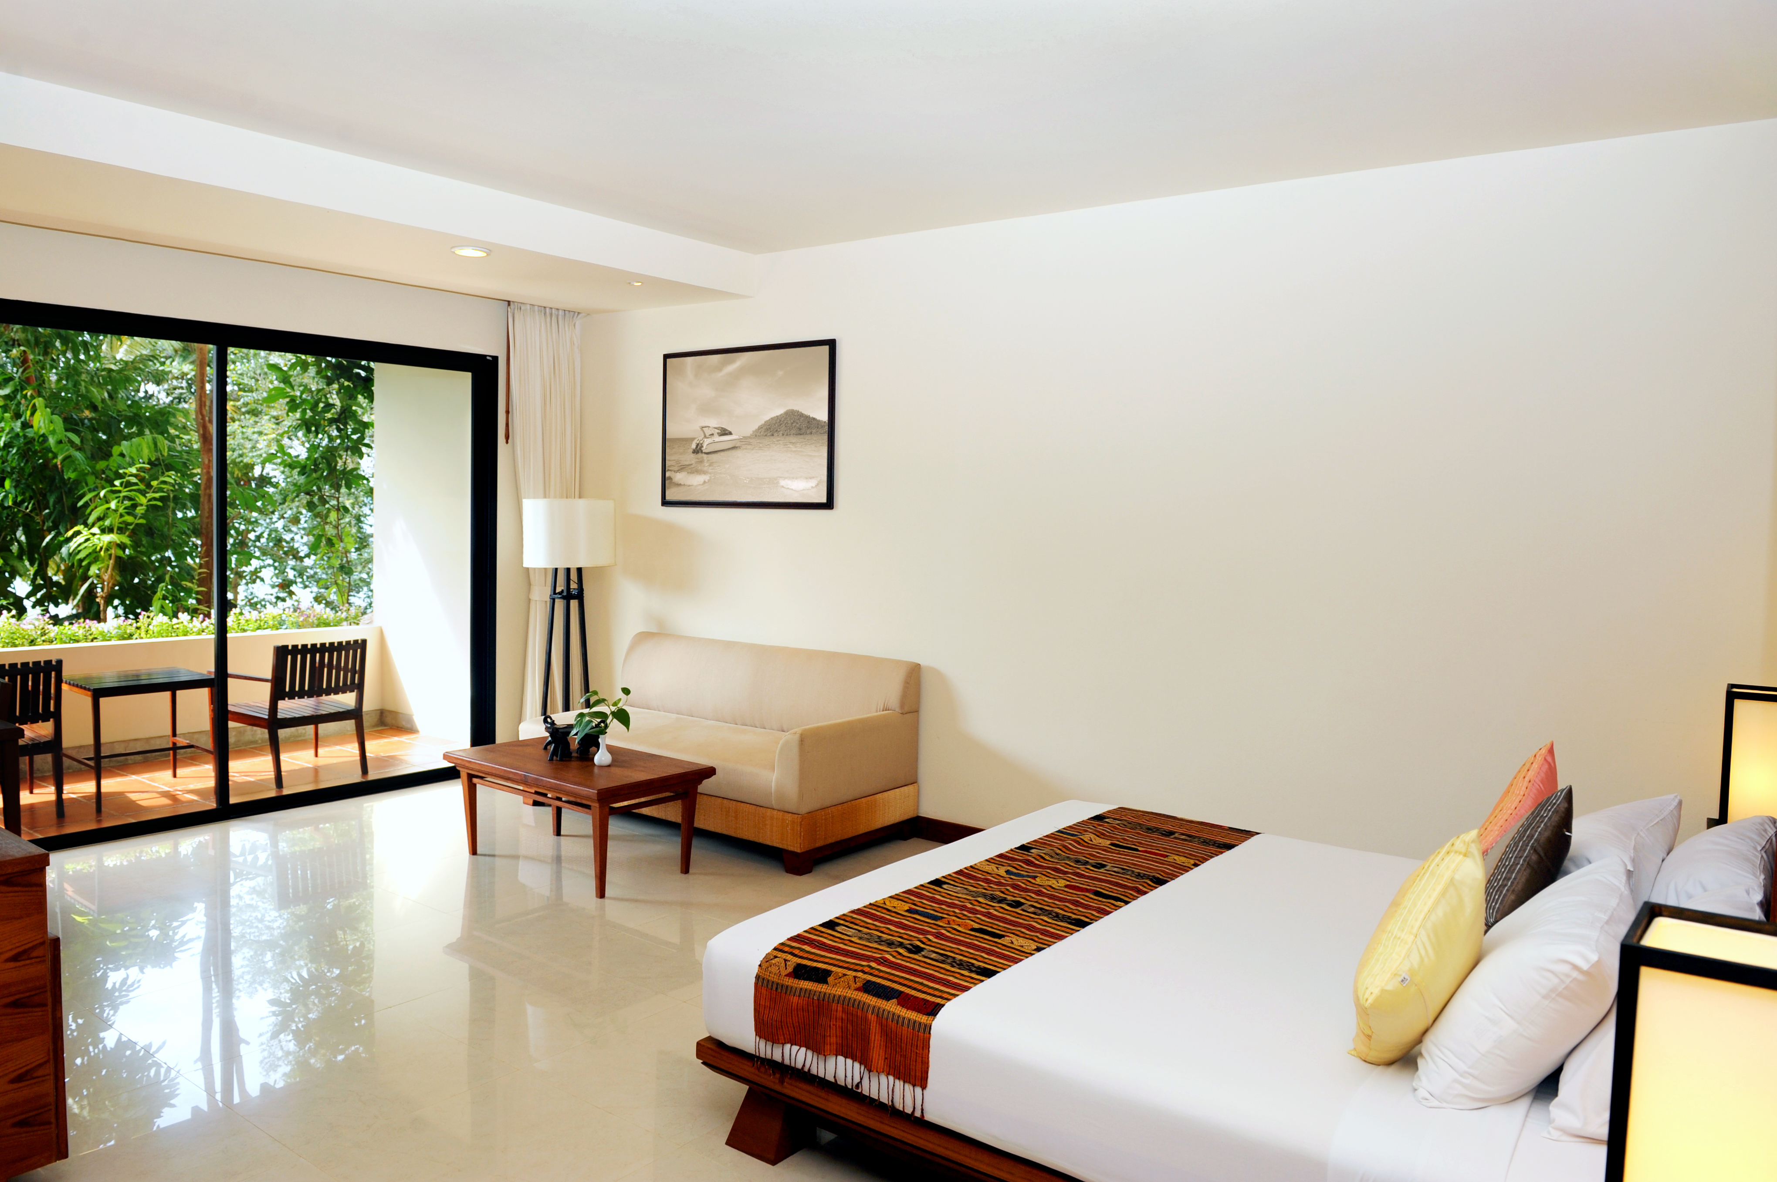San Francisco, Bernal Heights: Nestled between a yoga studio and a bakery, on a quaint street in this community-centered neighborhood, is the 40-room, modern-themed, Landon Hotel. While the primary purpose of the hotel is to house visitors from around the world, a secondary, almost mandated purpose, is as a gathering place for many of the community’s activities and calls to activism. No one can leave the hotel untouched by the sense of community.

Paris, Latin Quarter of the 6th Arrondissement: Since the 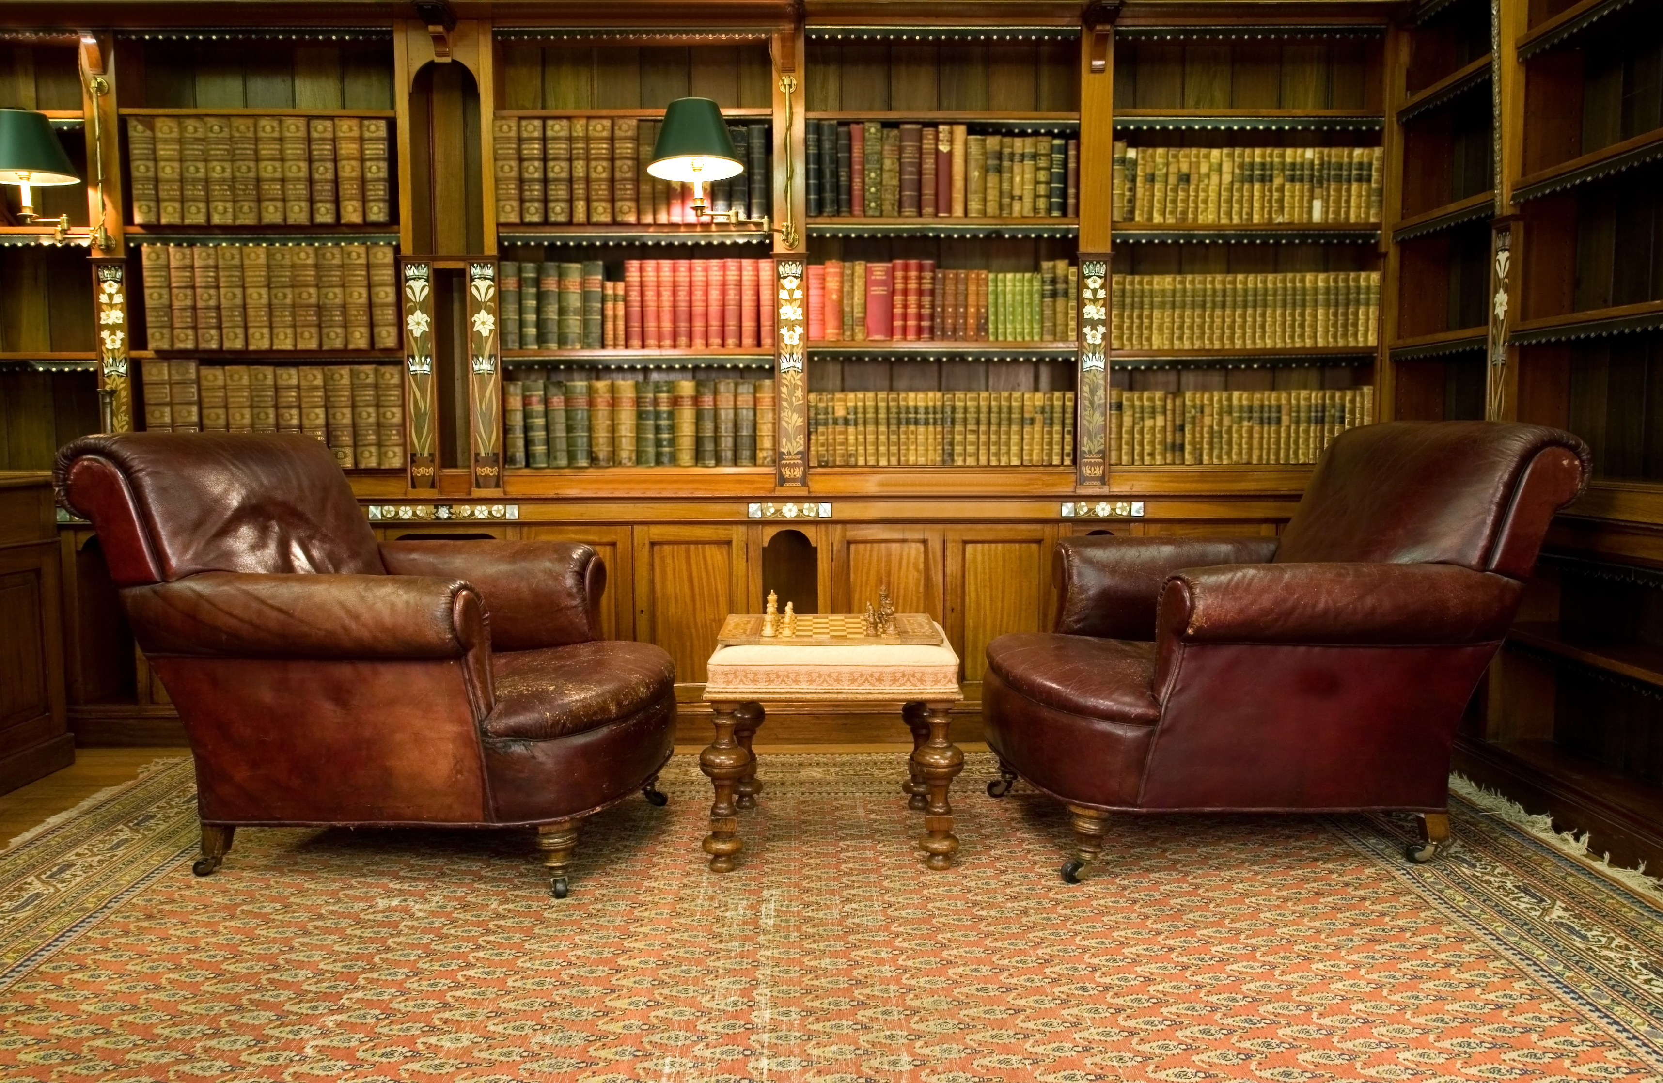Middle Ages, the Latin Quarter has been a neighborhood of artists, writers, and intellects, and the Landon exudes this in every brick of its building. It’s a common experience that a tourist finds himself derailed from an ordinary day of tourism, to sit in the vintage reading room of the Landon and debate politics, discuss literature, or recite poetry with natives, while sipping coffee amongst the hotel’s sizable book stacks.

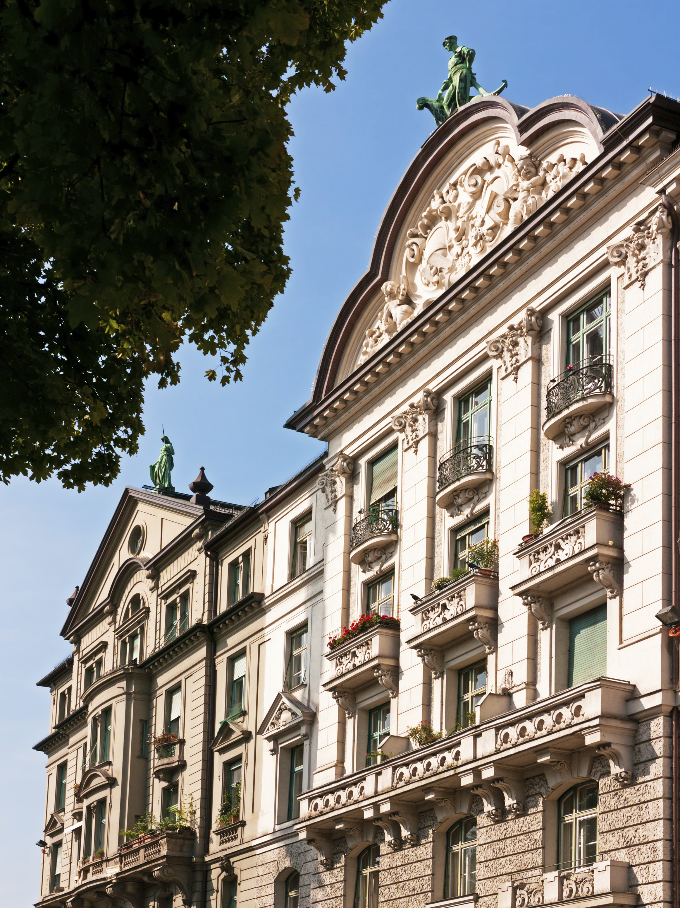Vienna, Eighth District: The Josefstadt: For those travelers who like living more like locales, The Landon in the Eighth District is simply heaven. This district is centrally-located, yet off the tourist map - as much of it is residential. However, the charm in the Eighth District is that you can lose yourself in “real” life by visiting the cafes, bars, galleries, and various unique shops tucked away in this unexpected gem of a place. Back at the hotel, every visitor is showered in luxury from the 600-thread count sheets to the surround sound theater system in every room - The Landon is the embodiment of comfort, style, and sumptuous living.

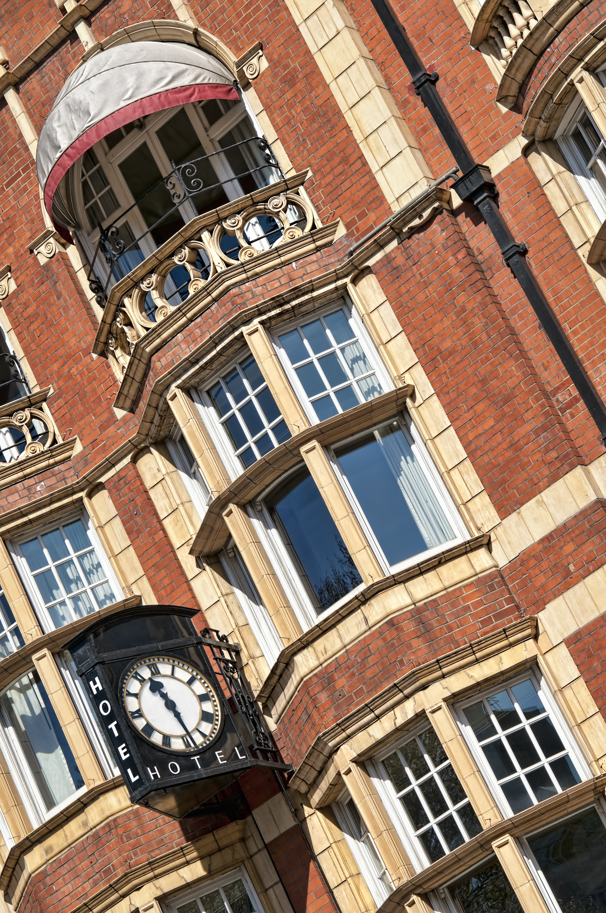

London, West End: The original Landon still perseveres after over 50 years, although it has since had a facelift to improve infrastructure. The West End Landon is in a neighborhood that has something for everyone - from theater to dining to historic sights. That said, The Landon is still far from being solely a tourist’s hotel. The community doesn’t just ebb and flow around the hotel - the community pours into the hotel, making The Landon an important venue for community activities and meetings. And the not-to-miss rooftop cafe is a great place for travelers and locals to engage over drinks, food, and good conversation.

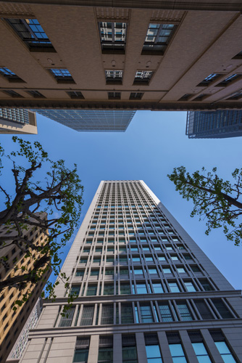

Tokyo, Business District: From business trips to family vacations, the Landon Hotel located in the heart of Tokyo is a perfect place to choose for your visit to this wonderful city.  Our 60 luxurious rooms are all equipped to make your stay not only comfortable, but memorable.  Between the relaxing and serene rooftop gardens, our authentic five-star Okonomiyak restaurant, and our experienced concierge to help you manage your way through the hustle and bustle of Tokyo - you'll feel right at home.

Munich, Schwabing: Nestled less than a mile away from the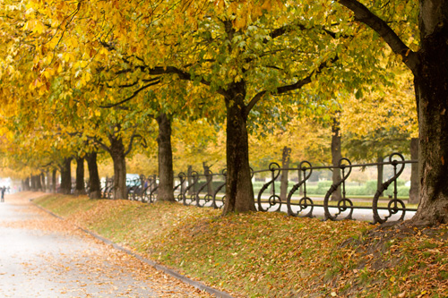 beautiful English Gardens, the Landon fits in perfectly with Munich's picturesque scenery.  Because of the hotel's great locale, traveling around the city is a breeze and many guests can easily walk or bicycle to several of Munich's historical sites, including the Bavarian National Museum, or perhaps the Munich Zoo, a wonderful spot for families.  Guests of the Landon are sure to enjoy their stay in one of our beautiful suites while being treated to our internationally-renowned service.

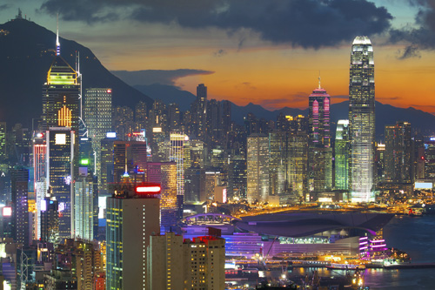Hong Kong, Kwun Tong: With floor to ceiling windows and an amazing view of the city lights below, the Landon Hotel located in the Kwun Tong neighborhood of Hong Kong is the choice of many professionals visiting the area.  Savvy and sophisticated, the Landon delivers a great place to slow down and relax amid the amazing landmarks of Hong Kong's fast-paced tempo, including Millennium City and the Manulife Financial Centre.

Los Angeles, Downtown: 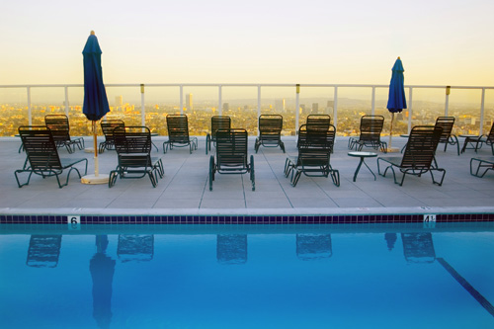[description]

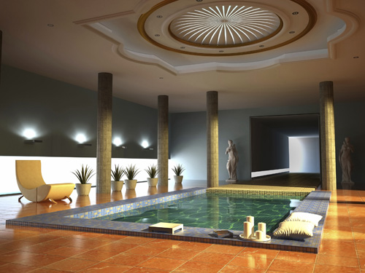New York City, Manhattan: Take a bite out of the big apple with the Landon hotel in Manhattan.  Comfy beds, memory-foam pillows, high-speed internet, and 24-hour room service are just a few amenities guests will enjoy. Our well-renowned Steak House is located at the top of our 33-story high rise in the middle of Manhattan, so you’ll have a spectacular view of the city below.  And in case you just want to rest your feet after a long day of exploring, the Landon has an in-house spa with yoga classes, a laser sauna, Swedish massage, and numerous treatments to soothe your body, mind, and soul. Let us spoil you at the Landon in Manhattan.